**INF10002** High Distinction Task

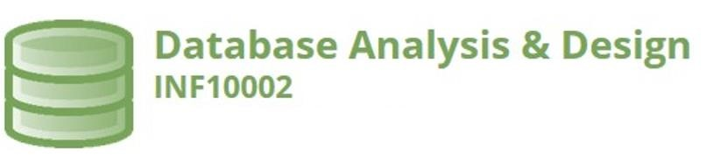

# High Distinction Task S1 2022

Student ID: 103181157

Student Name: Nguyen Nam Tung

**Part 1 – Business Narrative**

TANDT Automobile Rental is one of Melbourne's most reputable car rental companies. Young and energetic entrepreneur Nguyen Nam Tung founded this company in 2000 on Elizabeth Street in Melbourne's central business district. Several months ago, after the Covid-19 pandemic, Australian quarantine rules were removed, and many Australian nationals and international students have returned to the country for employment and education, increasing the demand for transportation. As a result, in order to meet this growing demand, several car rental locations have opened across Melbourne. However, managing many staff and locations can be challenging. Hence, an Access database can be utilised for more effective data management, resulting in better decision-making in the future.

Each branch has a unique ID, name, location, and customer service telephone number. There are a certain number of employees at each branch. A worker can only work in a single branch. Each employee has an ID, a name, and a phone number. Each location offers car rental services. Each car has a code, branch, manufacturing year, and colour. Some automobiles require maintenance before the renting process. However, a vehicle can only belong to one branch.

Customers can rent a car by contacting the branch. When a consumer wants to make a contract, they must provide their name, phone number, email address, and they will be assigned a unique identifier. The contract has a start date, an end date, and a weekly fee that must be paid.

The customer pays the service fees weekly until the contract expires. For each customer payment, the date and amount of the transaction are recorded. However, this service accepts only a limited number of payment methods, identified by method number and name (for example 1- Credit Card)

Several queries and visualisations can be utilised when creating a database, including:

* Which location has the greatest number of employees
* Which cars have the most sales
* Total Revenue per car brand
* Which payment method is the most popular

-

**Part 2 – ERDs and Relational Schema**

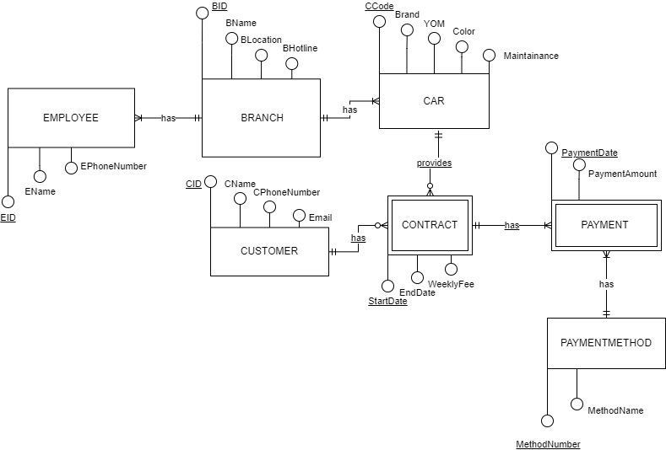

EMPLOYEE (EID, EName, EPhoneNumber, BID)

PK (EID)

FK (BID) REFERENCES BRANCH

BRANCH (BID, BName, BLocation, BHotline)

PK (BID)

CAR (CCode, Brand, YOM, Color, Maintainance, BID)

PK (CCode)

FK (BID) REFERENCES BRANCH

CUSTOMER (CID, CName, CPhoneNumber, Email)

PK (CID)

CONTRACT (CCode, CID, StartDate, EndDate, WeeklyFee)

PK (CCode, CID, StartDate)

FK (CCode) REFERENCES CAR

FK (CID) REFERENCES CUSTOMER

PAYMENT (CCode, CID, StartDate, PaymentDate, PaymentAmount, MethodNumber)

PK (CCode, CID, StartDate, PaymentDate)

FK (CCode, CID, StartDate) REFERENCES CONTRACT

FK ( MethodNumber) REFERENCES PAYMENTMETHOD

PAYMENTMETHOD (MethodNumber, MethodName)

PK ( MethodNumber)

**Part 3 – DB Solution (If using Access then file is to be uploaded to Canvas)**

**(If using SQL then Drop Table, Create Table, Insert Statements are pasted here)**

Paste here.

Here are all the tables in my Access database

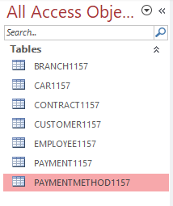

Here are the relationships between the tables

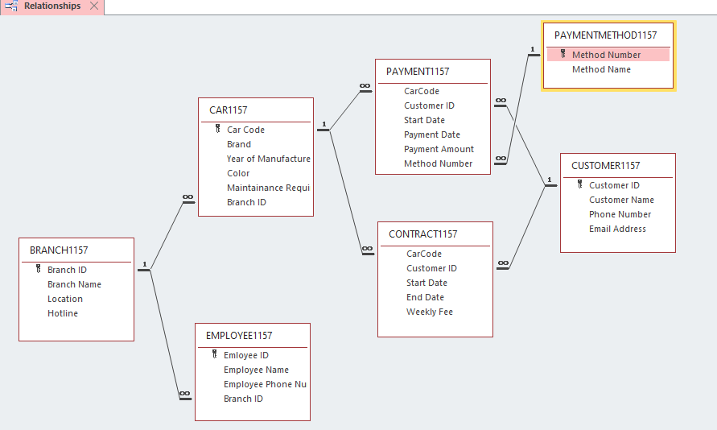

**Part 4 – Test Data (Diagram and/or Statements)**

Design Views/Datasheet views or Sql scripts - Paste here.

**CUSTOMER1157 TABLE:**

This is the table that contains my name and student ID, my tutor and convenor, a male and a female world leader

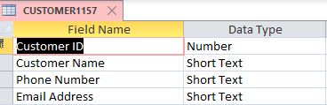

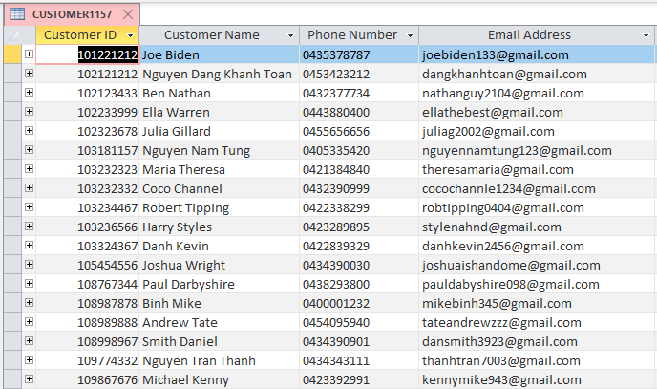

**BRANCH1157 TABLE**

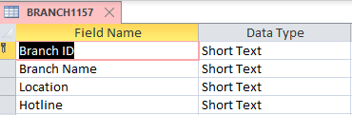

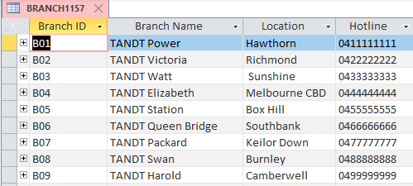

**CAR1157 TABLE**

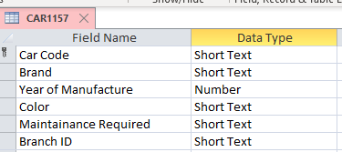

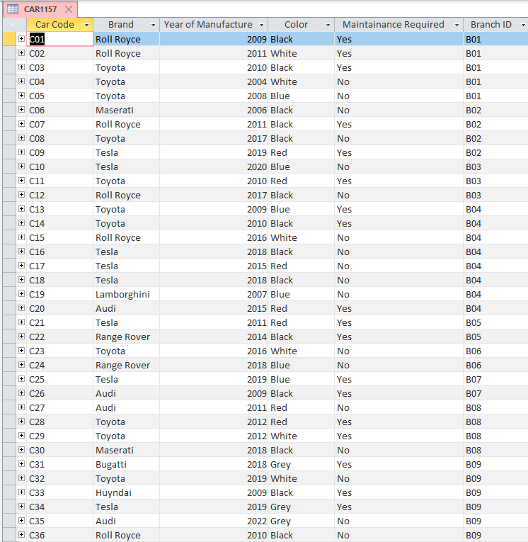

**CONTRACT1157 TABLE**

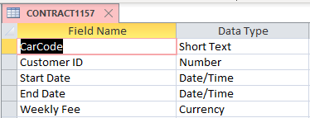

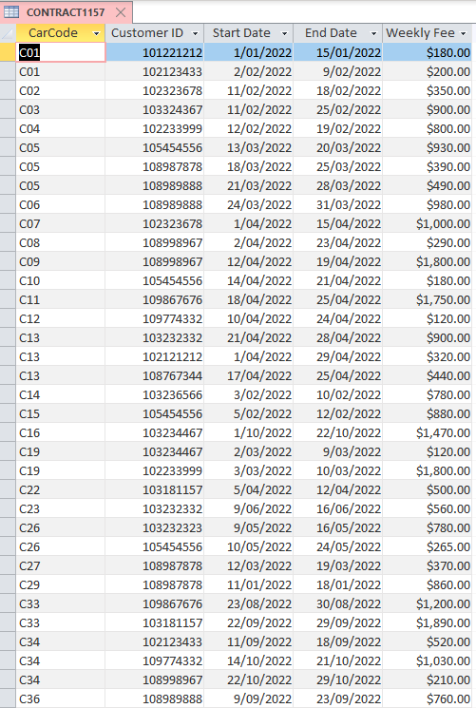

**EMPLOYEE1157 TABLE**

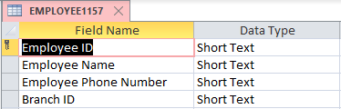

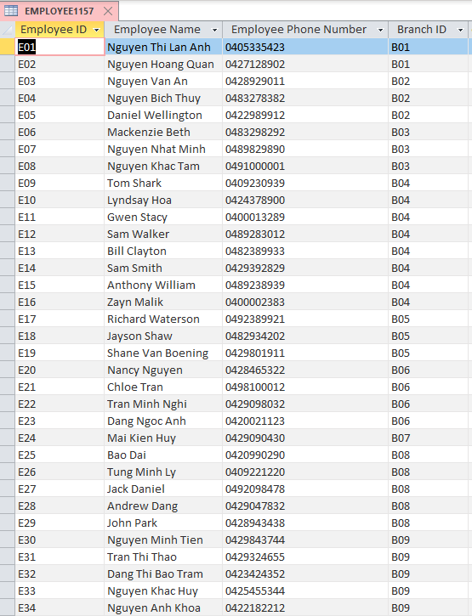

**PAYMENT1157 TABLE**

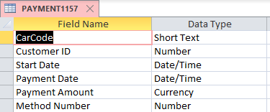

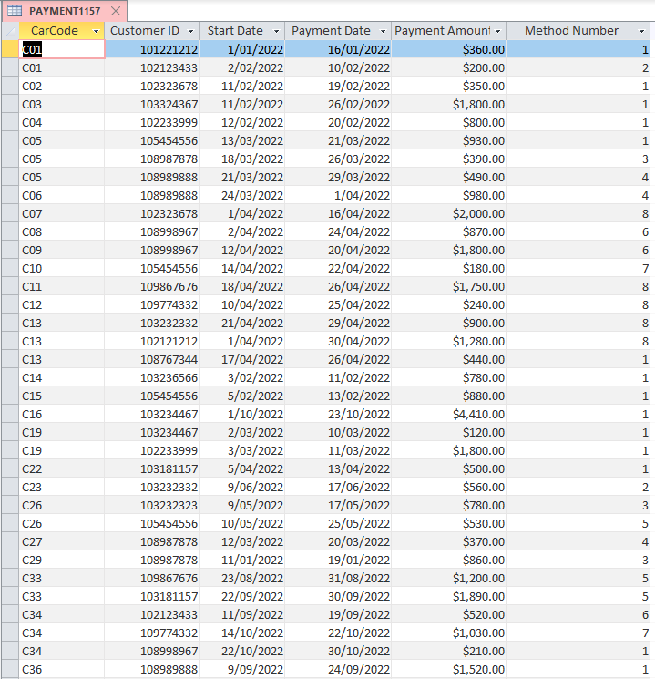

**PAYMENTMETHOD1157 TABLE:**

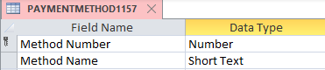

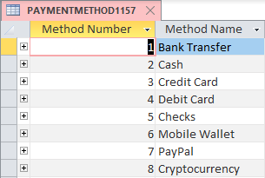

**Part 5 – Queries, Visualisations, (i.e. Queries or sql scripts)**

Query 1; Display the branch ID, branch name, branch location and the total number of employees in each brand (Elizabeth branch has the greatest number of employees)

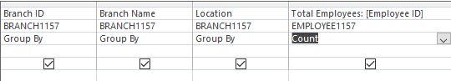

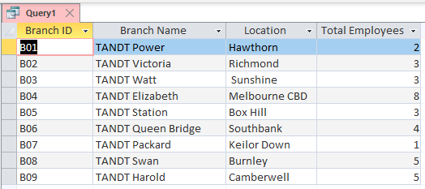

Query 2: Display the customer ID, customer name of customers that spend more than $400 in TANDT Rental service (Display my name, my tutor in my convenor)

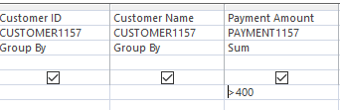

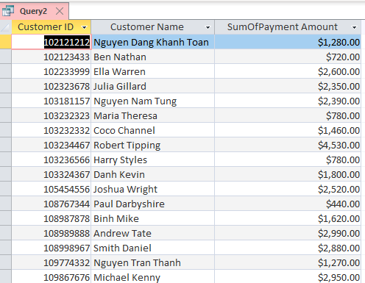

Query 3: Display the number of transactions used in each payment method (Bank transfer is the most common payment method)

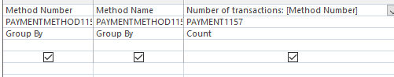

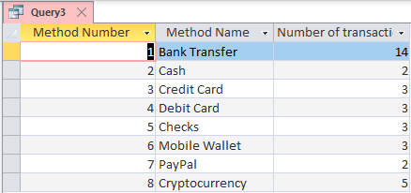

Query 4: Display all the total sum of payment (revenue) earned by each branch

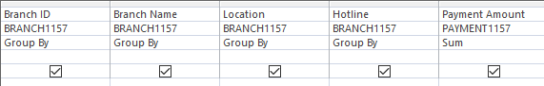

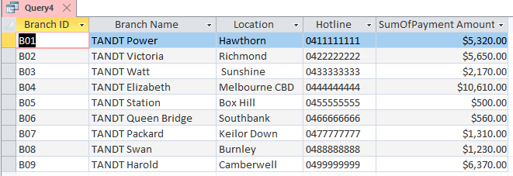

Visualization 1: Display the number of sales made by each car brand (Toyota has the highest sales)

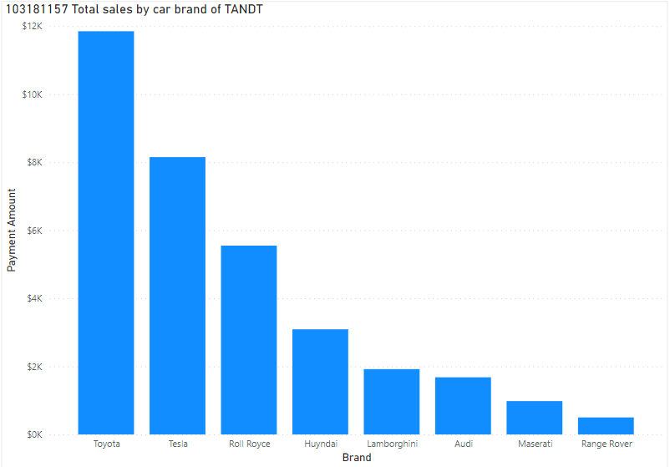

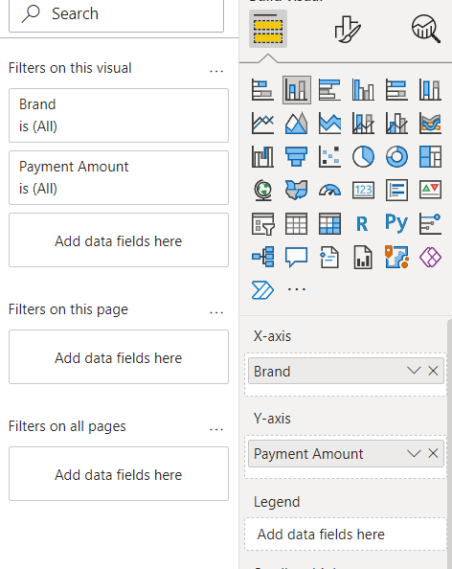

Visualization 2: Display the number of transactions made by each customer: (Display me, tutor and convenor)

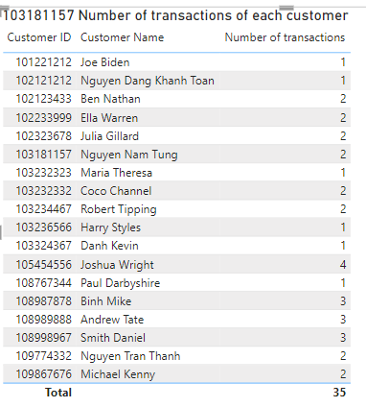

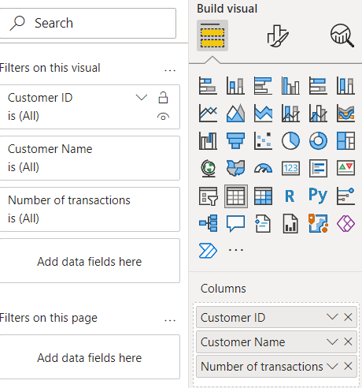

Visualization 3: Display the number of cars of each branch

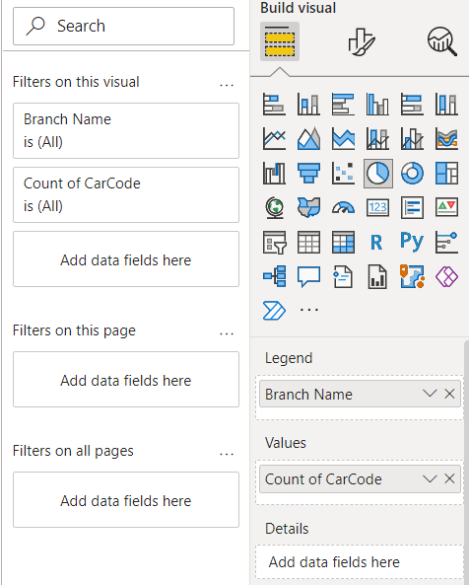

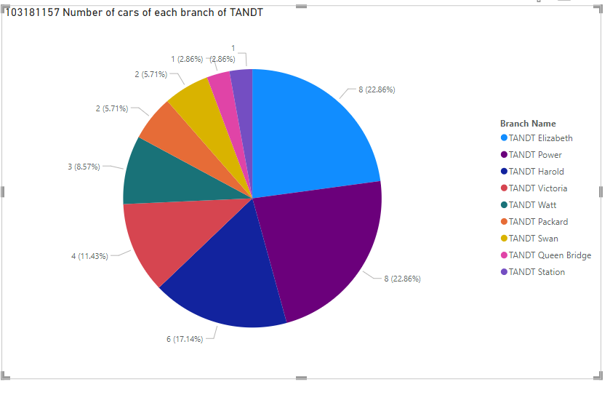

Visualization 4: Display the number of cars by brand in all branches of TANDT

